End-to-End Data Management Pipeline for a Recommendation System

- Execution screen Shots
- Final Report summary
- Github repository Link

Execution screen Shots
- python3 -m src.pipeline

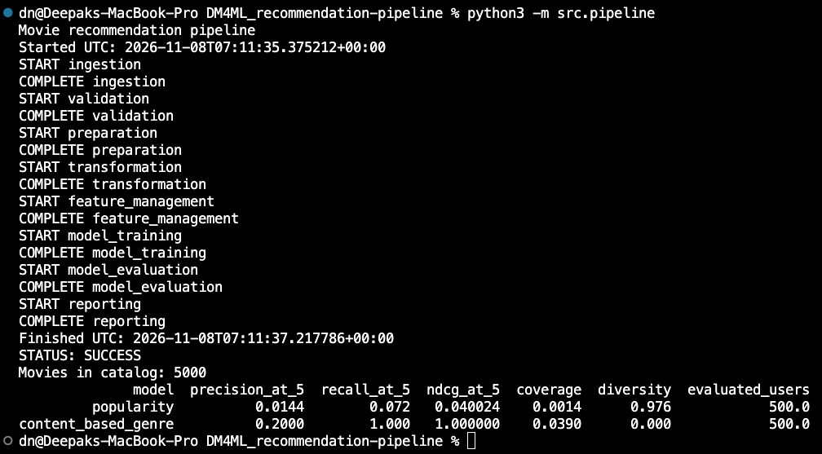

- python3 dags/workflow.py
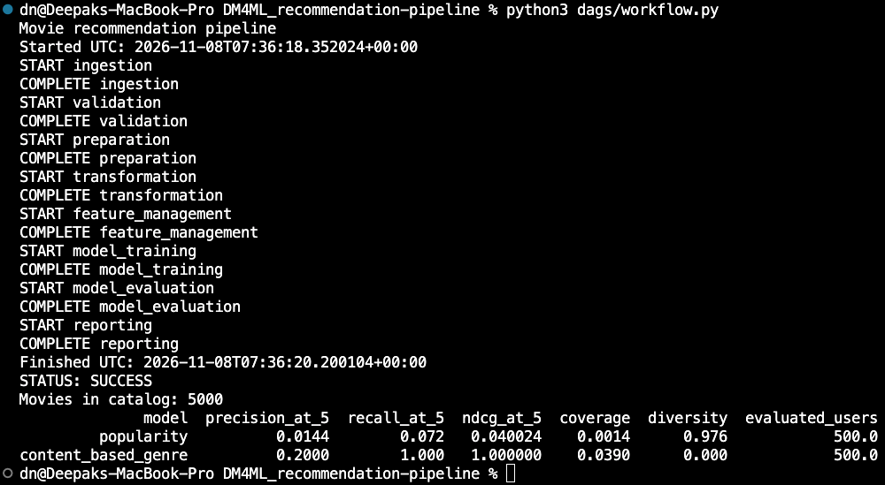

Final Report summary:

Github repository Link: https://github.com/2025ag05345git/DM4ML_recommendation-pipeline.git

